

Statistics and EDA - Module 09 – GDP Assignment

***Author***: Anish Mahapatra

***Email***: anishmahapatra01@gmail.com

* The analysis started off with data cleaning, transformations, treatment of NaN values post downloading and filtering the Union Territories into an archive folder
* It was followed by slicing of the dataset to separate current values and % Growth.
* Then, analysis on current prices of All india GDP was performed:
  + 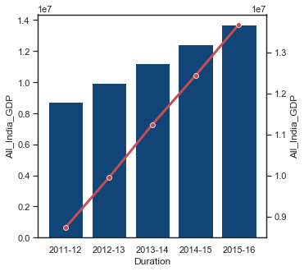
* This was followed by plotting % Growth for All india:
* 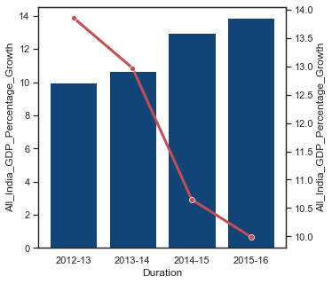
* Then, absolute prices for 2015-16 (Current Prices) at a State-Level was plotted:
* 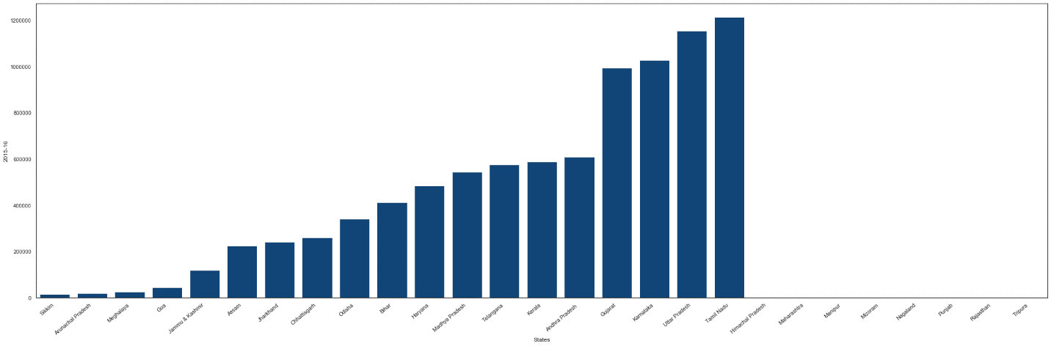
* Average % Growth of all states for all years was also plotted:

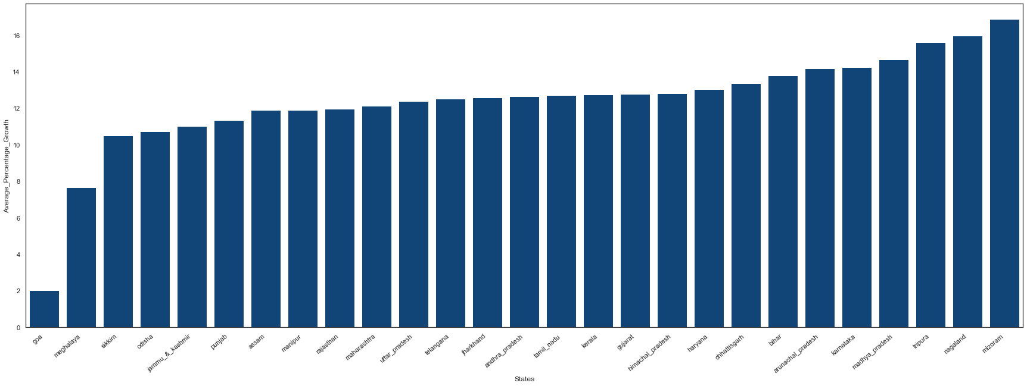

Insights for Part 1-A:

- Even through Nagaland has less absolute GDP, the growth rate (% Growth) of Nagaland is among the top 3 in India for the defined time-period

- The North-Eastern states of Mizoram, Nagaland and Tripura are in their prime growth. More focus should be given to developing state instead of focusing on larger GDPs as this would empower the states and result in quick wins.

- Goa, being a prime tourist-destination should be focused more on to achieve higher year-on-year growth!

- Lessons should be taken from the North-Eastern states on how to continuously improve on % Growth year on year

- <b>Sikkim</b> has not been able to catch up to the growth of the nation and special laws should be formed to help improve the state

**Part 1-B**

Plot for GDP per Capita:

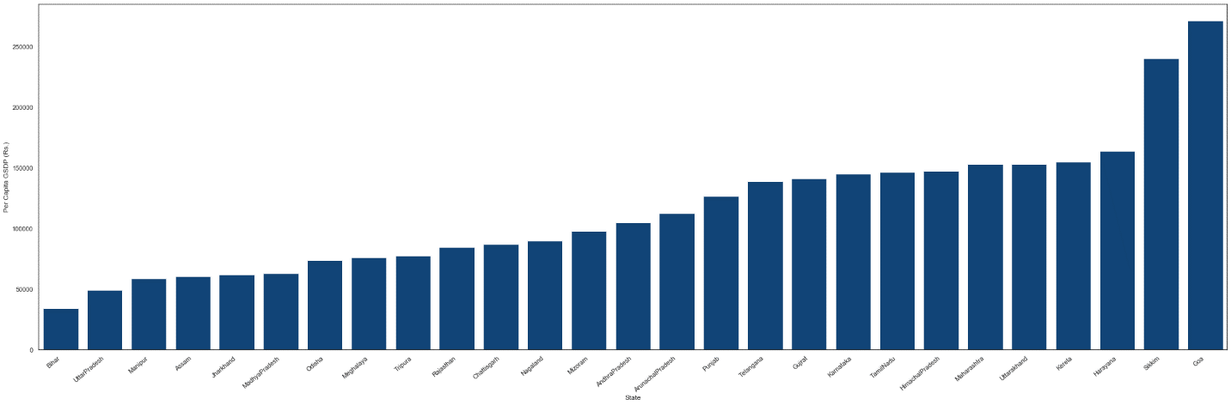

Contribution of Primary, Secondary and Tertiary as a percentage of Total State GDP (GSDP)

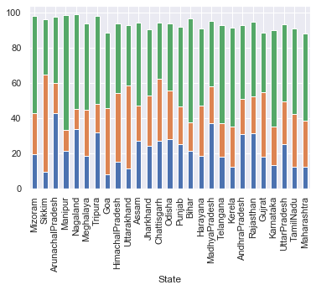

**Recommendations for Part 1- B, post segmentation:**

* C1 - The focus should be more construction to ensure that the rate of growth is future-proof and does not over-saturate

* C1 - For professional services to contribute to the GDP at the current rate, more focus should be on empowering citizens to keep up the disposable income. This can be done with the help of better employment opportunities.

* C2 - Focus should continue manufacturing, not only locally, but also to increase imports, which will lead to higher GDP per capita

* C2 - Trade, repair and hotels can improve This can be done with a higher focus on tourism and how we can get people outside of these cities (and maybe even country!) to come and spend their disposable income here to ensure higher GDP per capita!'

* C3 - This is a definite area where much more focus should be given to Manufacturing as the income from Manufacturing should be far ahead from Crops

* C3 - Taxes on products as a major source of income is not a positive sign, and the sources of GDP from other sub-sectors need to improve

* C4 - It's time to move away from Agriculture. More focus should be given in automating manual tasks and improving machines in agriculture so that the general public has more time to explore other areas

* C4 - Manufacturing jobs should be improved considerably as this will be a gateway to a better life

#### Additional Insights:

* Foreign and Indian Multinational companies should be invited to set up more manufacturing units in C3 and C4 states as they have a lot of cheap labor and opportunities

* More grass-root enablement should happen in C4 States, as this will enable the public to automate a lot of manual tasks in agriculture, and will enable them to get more empowered generation to generation

Part – 2

Heatmap of drop out rates versus per Capita GDP for the year 2014-15

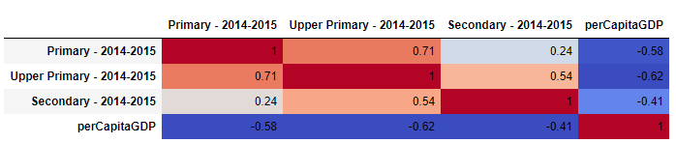

Heatmap of drop out rates versus population for the year 2014 – 15

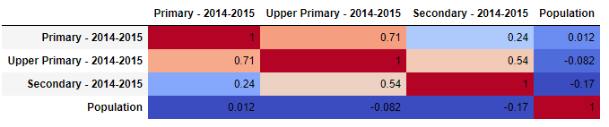

Insights from Part – 2:

* From the correlation plot made, we observe that there is no significant correlation between population and drop out rates and any correlation between them would be random

- Having seen the trend of dropout rates, we must give considerable thoughts to the below points:

* Dropout rates are not dependent on the population. Being in a State where there is more population is not an excuse to not contribute to the community.

Hypothesis: When the primary and upper-primary dropout rates are higher, there is a higher opportunity that the citizens will get into entrepreneurship, leading to higher per capita GDP in the state.